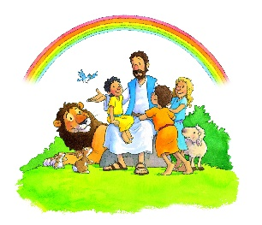
Little Lambs Preschool Calendar
2023 – 2024

August 4th Preschool Closed for Teacher Planning
August 7th First Day of Preschool
August 10th First Day of V.P.K
September 4th Preschool Closed for Labor Day
October 16th No V.P.K Teacher Planning Day
November 20th – 24th No V. P. K Thanksgiving Break
November 23rd & 24th Preschool Closed “Happy Thanksgiving”
December 25th – 29th V. P. K Closed Christmas Break***
December 25th Preschool Closed “Merry Christmas”
January 1st Preschool Closed “New Year’s”
January 1st – 5th V. P. K Closed Winter Break
January 8th No V.P.K Teacher Planning
January 15th Preschool Closed- M.L King Day
February 19th V. P. K Closed Presidents’ Day
March 8th No V.P.K Teacher Planning
March 25th – 29th V. P. K Closed for Spring Break ***
March 29th Preschool Closed for Good Friday
April 26th V.P.K Closed
May 24th Last Day of V. P. K Graduation
May 27th Preschool Closed for Memorial Day
May 31st Preschool Closed for Teacher Planning
July 4th Preschool Closed “Happy Fourth of July”

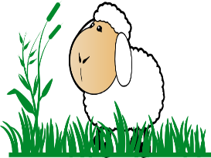
**** Preschool May Close Due to Lack of Attendance

